1. 
2. **git rm --cache** <file_path>  
   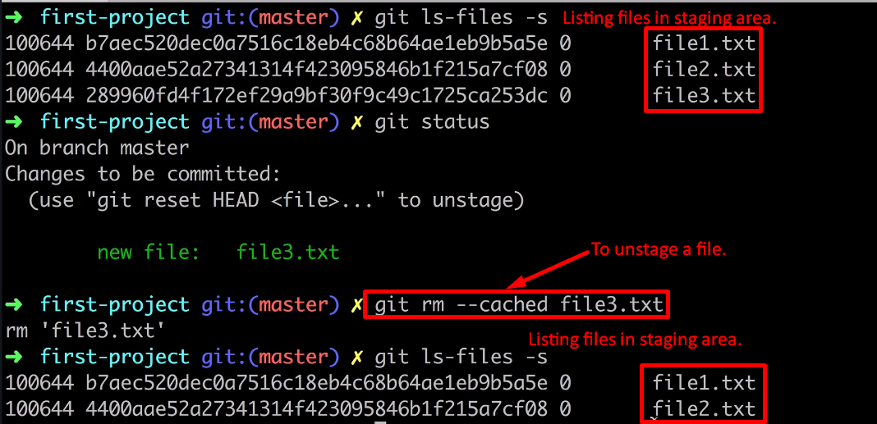
3. **NOTE**:   
   git rm --cache <file_path>  
   will unstage the specific file. It will not remove the changes from the file in a commit. If you want to do so, we have different commands.
4. 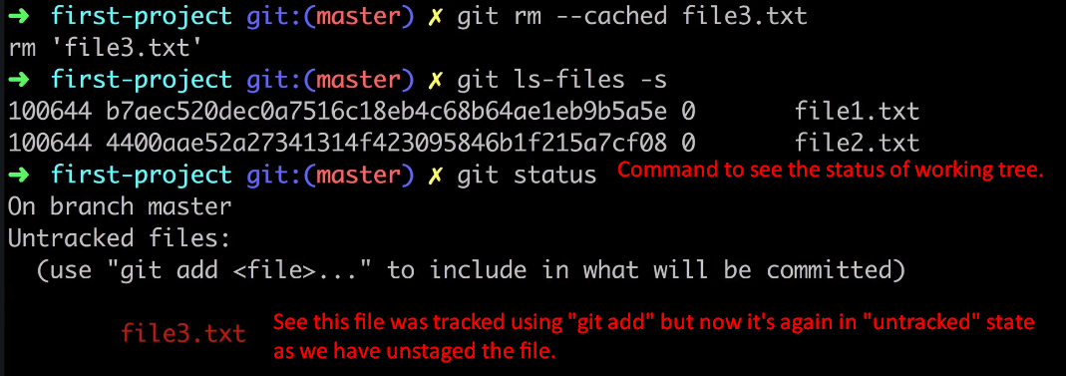
5. 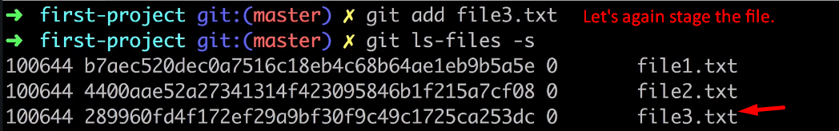
6. **Next Lec**:

Commit.